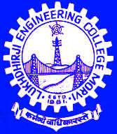
Lukhdhiraji Engineering College
Mechanical Engineering Department

Subject: Oil Hydraulic and Pneumatics
Code: 3151913
Semester: 5th Mechanical
Faculty: Prof. H. D. PATEL, Prof. A.B KHANT
Assignment-2: Valves used in hydraulic and pneumatic system

List of Questions:

- What is direction control valve? Draw symbols of different direction control valve with application.
- Explain working of flow control valve.
- Explain working of pressure control valve.
- Explain different non return valves used in hydraulic and pneumatic system.
- Explain construction and working of 4/3 direction control valve with neat sketch.
- Write short note on spool type valve.
- Discuss selection criteria of valve for circuits.
- Discuss the control technique used in DCV

