Lukhdhirji Engineering College, Morbi
Department of Mechanical Engineering
Assignment 5- Free vibrations and damped free vibrations (CO4)
Subject: DYNAMICS OF MACHINERY (3151911) Semester : 5th
Year : 2022-23
 | A vertical spring mass system has a mass of 0.5 kg and an initial deflection of 0.2 cm. find the spring stiffness and the natural frequency of the system.
 | A pump is supported on a spring and a damper. The spring stiffness is 6000N/m and the damper offers resistance of 480 N at 3.5m/s. The unbalanced mass of 0.6 kg rotates at 40mm radius and total mass of the system is 80Kg. The pump is running at 500rpm. Determine: i) damping factor, ii) amplitude of vibration iii) resonant speed and amplitude at resonance.
 | The mass 'm' is hanging from a chord attached to the circular homogeneous disc of mass 'M' and radius 'R' as shown in Figure. The disc is restrained from rotating by a spring attached at radius 'r' from the centre. If the mass is displaced downwards from rest position, determine the frequency of oscillations. As shown in Fig. 1
 | Determine the natural frequency of the mass m = 15 Kg as shown in figure. Assuming that the cords do not stretch and slide over the pulley rim. Assume that the pulley has no mass. Take K₁ = 8000 N/m and K₂ = 6000 N/m. Fig. 2
 | A machine having mass of 100kg is supported on a spring which deflects 20 mm under the dead load of machine. A dashpot is fitted to reduce the amplitude of free vibration to 10% of its initial value in two complete oscillations. Determine the stiffness of the spring, critical damping coefficient, logarithmic decrement, damping factor and frequency of damped-free vibration.
Two identical rotors are attached to the two ends of a stepped shaft as shown in Figure. Each rotor weighs 450 Kg and has radius of gyration of 0.38 m. The diameters of the shaft are 0.75 m for first 0.25 m length, 0.1m for next 0.1m length and for the remaining length 0.0875 m is the diameter. The total length of the shaft is 0.6 m. Find the frequency of free torsional vibrations of the system and position of the node from either masses. Assume modulus of rigidity as 80 x 109N/m2.
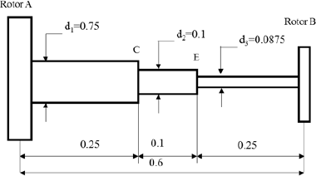
Figure 3
 | 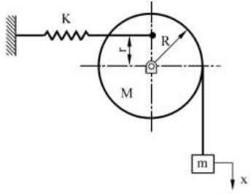  Figure 1 | 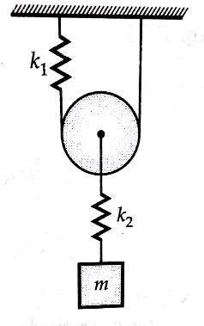  Figure 2

