Subject/  Subject Code | Semester/  Branch | Issue Date | Due Date
Analysis and Design of Algorithms/ 3150703 | 5thSem. /IT Engineering

Assignment# 1
Sr. No. | Question | CO Mapping
 | Find out time complexity for the following pseudo code using O- notation.  for(i = 0; i < n; i++)  {  for(j = n ; j > 0 ; j--)  {  if( i < j )  c = c + 1;  }  } | CO1
 | Sort the letters of word “EDUCATION” in alphabetical order using insertion sort. | CO3
 | Sort the given elements with Heap Sort Method: 20, 50, 30, 75, 90, 60, 25, 10, 40. Illustrate step by step procedure. | CO3
 | What are different types of asymptotic notations explain in terms of best case, average case and worst case order of growth of function.
 | Why height of binary is O(logn)? Explain and prove.

Subject/  Subject Code | Semester/  Branch | Issue Date | Due Date
Analysis and Design of Algorithms/ 3150703 | 5thSem. /IT Engineering

Assignment# 2
Sr. No. | Question | CO Mapping
1. | Solve following recurrence using master method T(n) = 9T(n/3) +n | CO2
2. | Solve following recurrence using recursion tree method: T(n) = 3T(n/3) + n^3. | CO2
3. | Check the correctness for the following equality. 5n3 + 2n = O(n3) | CO2

Subject/  Subject Code | Semester/  Branch | Issue Date | Due Date
Analysis and Design of Algorithms/ 3150703 | 5thSem. /IT Engineering

Assignment# 3
Sr. No. | Question | CO Mapping
1. | Discuss knapsack problem using dynamic programming.Solvethefollowing knapsack problem using dynamic programming.Therearethree objects, whose weights w (w1, w2, w3) ={1, 2, 3} andvaluesv(v1,v2,v3)={2, 3, 4} are given. The knapsack capacity M is 3 units. | CO3
2. | Given two sequence of characters, X={G,U,J,A,R,A,T}, Y = {J,R,A,T} obtain the longest commonsubsequence. | CO3
3. | Write equation for Chained matrix multiplication using Dynamic programming. Find out optimal sequence for multiplication:  A1 [5 × 4], A2 [4 × 6], A3 [6 × 2], and A4 [2 × 7]. Also give the optimal parenthesization of matrices. | CO3

Subject/  Subject Code | Semester/  Branch | Issue Date | Due Date
Analysis and Design of Algorithms/ 3150703 | 5thSem. /IT Engineering

Assignment# 4
Sr. No. | Question | CO Mapping
1. | Solve the following Knapsack Problem using greedy method. Number ofitems=5,knapsackcapacityW=100, weight vector={50,40,30,20,10} and profit vector={1,2,3,4,5} | CO3
2. | Generate Huffman codes for the following Letters:  Letters: A B C D E  Frequency: 24 12 10 10 8 | CO3
3. | Use Greedy Algorithm to find an optimal schedule for following jobs with n=6.  Profits: (P1,P2,P3,P4,P5,P6) = (20,15,10,7,5,3)  Deadline: (d1,d2,d3,d4,d5,d6) = (3,1,1,3,1,3) | CO3

Subject/  Subject Code | Semester/  Branch | Issue Date | Due Date
Analysis and Design of Algorithms/ 3150703 | 5thSem. /IT Engineering

Assignment# 5
Sr. No. | Questions (Answer following questions with respect to graph given) | CO Mapping
1. | Apply Shortest Path Algorithm and find shortest paths from node 1 to all the remaining nodes. | CO3
2. | Apply topological sorting. | CO3
3. | Apply BFS. | CO3

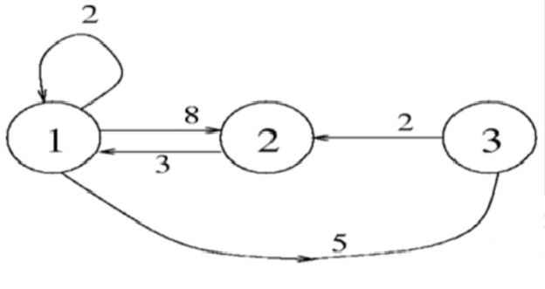

Subject/  Subject Code | Semester/  Branch | Issue Date | Due Date
Analysis and Design of Algorithms/ 3150703 | 5thSem. /IT Engineering

Assignment# 6
Sr. No. | Questions (Answer following questions with respect to graph given) | CO Mapping
1. | Give solution of 4 Queens Problem using Backtracking Method. | CO4
2. | Given a String a a a a a b and text a a b, apply Rabin-Karp string matching algorithm. | CO4
3. | Given a String a b c d e f g h and text d e f, apply KMP string matching algorithm. | CO4
4. | Give two examples each for polynomial and non-polynomial problems. Illustrate why a problem is polynomial or non-polynomial. | CO5

