L.E.College – Morbi Mechanical Engineering Department

GTU MID Sem Exam May 2023

SUBJECT NAME: Fundamental of Machine Design SUBJECT CODE: 3141907 Date: 18 / 05 / 2023 Time: 11:00 to 12:30

Q.1 (a) | Define the following terms:  - Factor of Safety  - Modulus of Elasticity  - Polar Moment of Inertia | 3 | CO1 | R
(b) | Explain the Perpendicular axis theorems for moment of inertia. | 3 | CO1 | U
(c) | Determine the moment of inertia of following T-section about X-X and Y-Y axes through the center of gravity of the section.  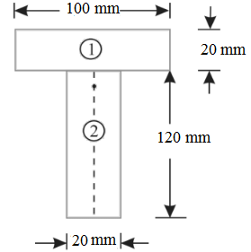 | 4 | CO1 | A
Q.2 | Derive the relation between modulus of elasticity, modulus of rigidity & Poisson’s ratio. | 5 | CO1 | U
 | OR
Q.2 | Derive the relation $\frac{σ_{b}}{y}=\frac{M}{I}=\frac{E}{R}$ with usual notations. | 5 | CO1 | U
Q.3 | Design a knuckle joint to transmit 150 kN. The design stresses may be taken as 75 MPa in tension, 60 MPa in shear and 150 MPa in compression. | 8 | CO2 & CO3 | E
 | OR
Q.3 | The load on a bolt consists of an axial pull of 10 kN together with a transverse shear force of 5 kN. Find the diameter of bolt required according to 1. Maximum principal stress theory; 2.Maximum shear stress theory; 3. Maximum principal strain theory; 4. Maximum strain energy theory | 8 | CO2 & CO3 | A
Q.4 (a) | Define equivalent twisting moment and equivalent bending moment. State when these two terms are used in design of shafts. | 3 | CO2 & CO3 | U
(b) | A line shaft rotating at 200 r.p.m. is to transmit 20 kW. The shaft may be assumed to be made of mild steel with an allowable shear stress of 42 MPa. Determine the diameter of the shaft, neglecting the bending moment on the shaft. | 4 | CO2 & CO3 | A
 | OR
(b) | A solid shaft is transmitting 1 MW at 240 r.p.m. Determine the diameter of the shaft if the maximum torque transmitted exceeds the mean torque by 20%. Take the maximum allowable  shear stress as 60 MPa. | 4 | CO2 & CO3 | A
***ALL THE BEST***

