L.E.COLLEGE MORBI
MECHANICAL ENGINEERING DEPARTMENT
MID SEM EXAMINATION AUG-2017 BE SEM 3rd MECHANICAL
MATERIAL SCIENCE & METALLURGY 2131904
TOTAL MARKS=30 TIME: 1.5 Hrs DATE:21/8/2017
Instructions: 1. Make suitable assumptions wherever necessary.
2. Figures to the right indicate and Answer must be in brief :full marks.
 | ATTEMPT ANY SIX
Q1 | A | What is lath martensite? | 05
 | B | Define sizing
 | C | What is curie point?
 | D | Following figure is represent Which heat treatment process.  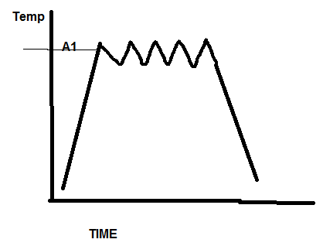
 | E | What is a univariant system?
Q2 | “Eutectic composition usually does not show coring where as a solid solution may show coring” why? |  | 05
Q3 | “ Annealing is not final heat treatment process of hypereutectoid steel”. Justify |  | 05
Q4 | Why FCC metals are in general more ductile than BCC and HCP? |  | 05
Q5 | Evaluate “ it is difficult to detect irregular shape radial defects in large rings by magnetic particle test”. |  | 05
Q6 | List the characteristic required for a metal powder. Explain any three in term of importance in powder metallurgy process. |  | 05
Q7 | With neat sketch of iron-iron carbide diagram, determine the amount of the following phases present in a 1.1% carbon steel under equilibrium conditions. (i) Austenite and cementite just above eutectoid temperature.  (ii) Pro eutectoid cementite, pearlite and total cementite at room temperature. |  | 05
Q8 | “Hardening of steel is followed by tempering”. Justify the statement. |  | 05

