REPORT
SHABDARTH 2.0
9th APRIL 2019
On 9/4/2019, a memorable event “SHABDARTH 2.0 – Machine se mehfil tak” was organized in our college by ignite team. Many students participated in it.
Shabdarth is basically literature based open mic event. This event can build up student literature power on wards. Many students participated in this. Not only students but some respected faculties like Dabhi sir, Garwaliya sir are also participated to make environment more live. We started our event on 9 o’clock sharp in the morning. We invited Ruchira mam(Diploma faculty), KAVI JALRUP (writer) and Jagrutima’m as a jury member for SHABDARTH 2.0. All participated performed very well and judges also encouraged they all. One special performance also given by Mali sir (Chairman of IGNITE, LEC)
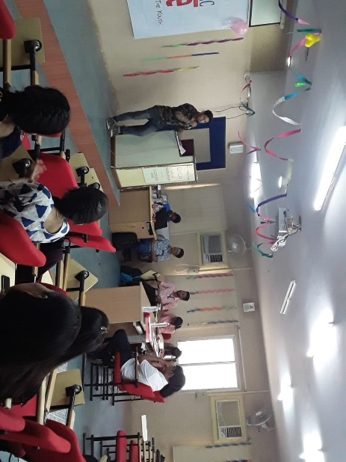 | 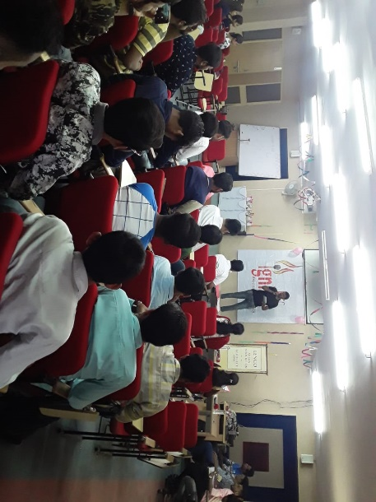
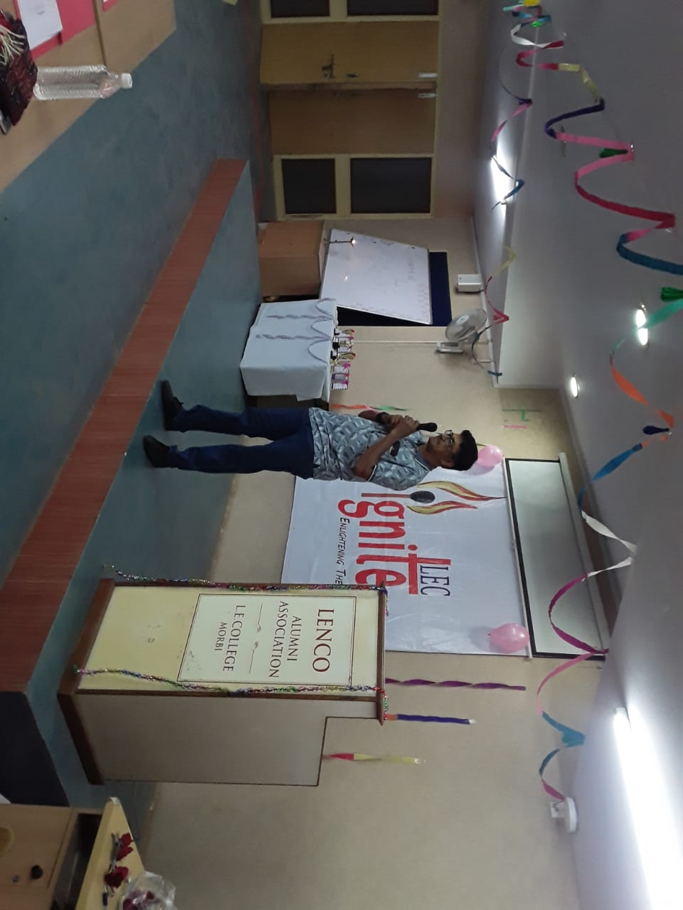MALI SIR | 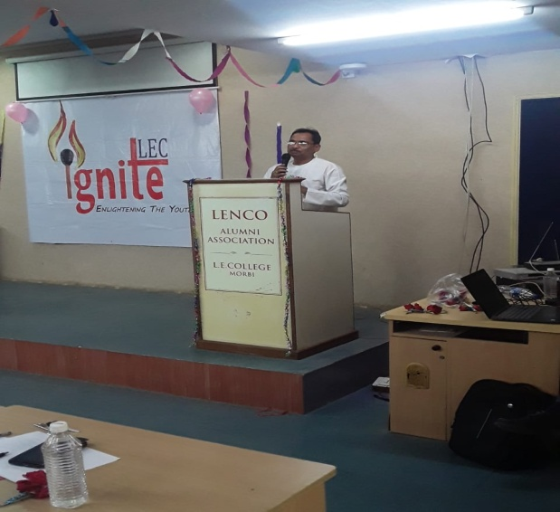DABHI SIR
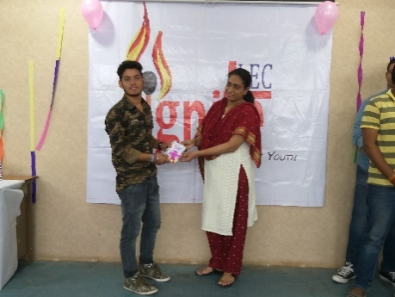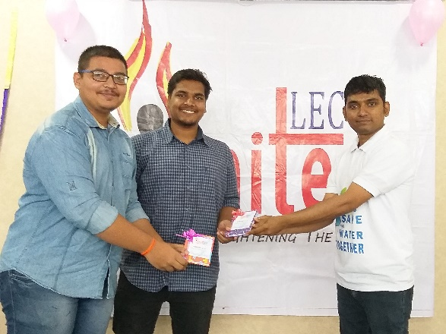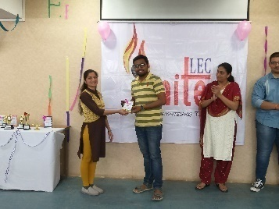
2nd 1st 3rd

