Report On ‘Treasure Hunt’
Date: 16 Aug, 2018
We organised a Treasure Hunt on Harry Potter theme. This event was for all year students of L.E.C. The ignite team worked together and planned the whole event in a very short period. The event started at 7:30 am on 16th. We selected 250 students via Google form and kept a Aptitude test to finalize the best 75 participants. The aptitude test had 10 objective questions (6 aptitude based and 4 Harry Potter based) and we kept negative marking system (+4 for one correct and -1 for one wrong). Finally, we selected 15 teams with random 5 people in each team. The event was spread across the whole campus (Old and new).
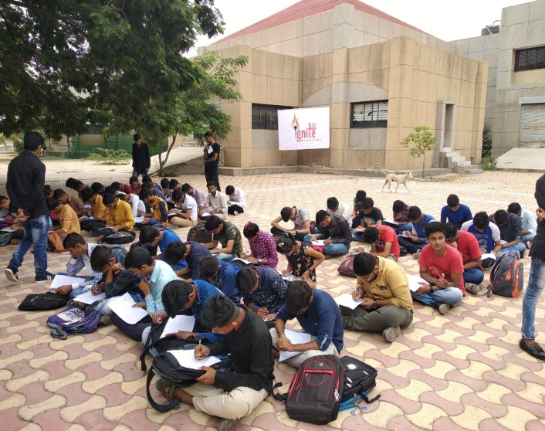  Participant | 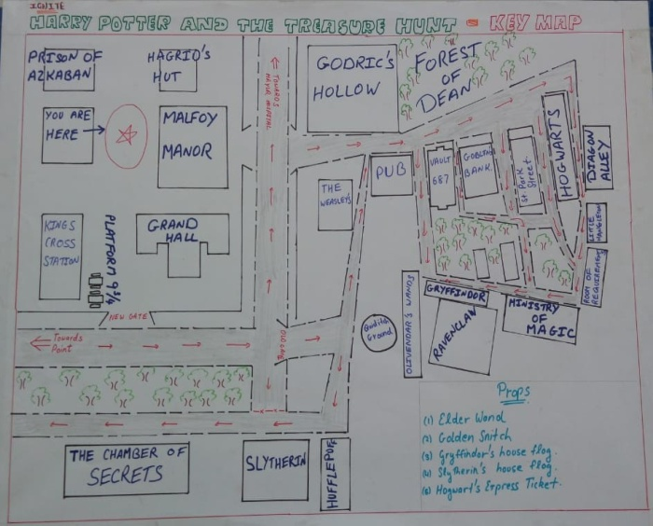  Map

We named the buildings according to the places in Harry Potter movies and created a map as above. Next, we created 15 set of 5 clues in each set. These 5 clues would lead them to different places. We also panned props like Elder’s Wand, Golden Snitch, Platform ticket and Gryffindor and Slytherin’s banner. They(participants) need to find one from each place the clue refers to. Finally, when they get all the 5 props, there was a final clue hidden in these clues. And it would lead to the Final place and any team to come first at that location with all the props wins. For the clues we hided the clues in form of QR code. We awarded the winner team with a trophy and certificates.

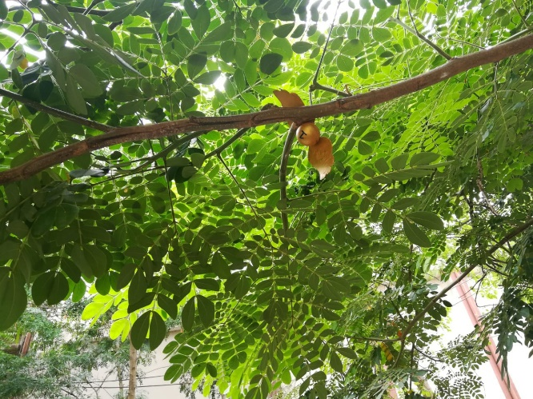  Golden Snitch | 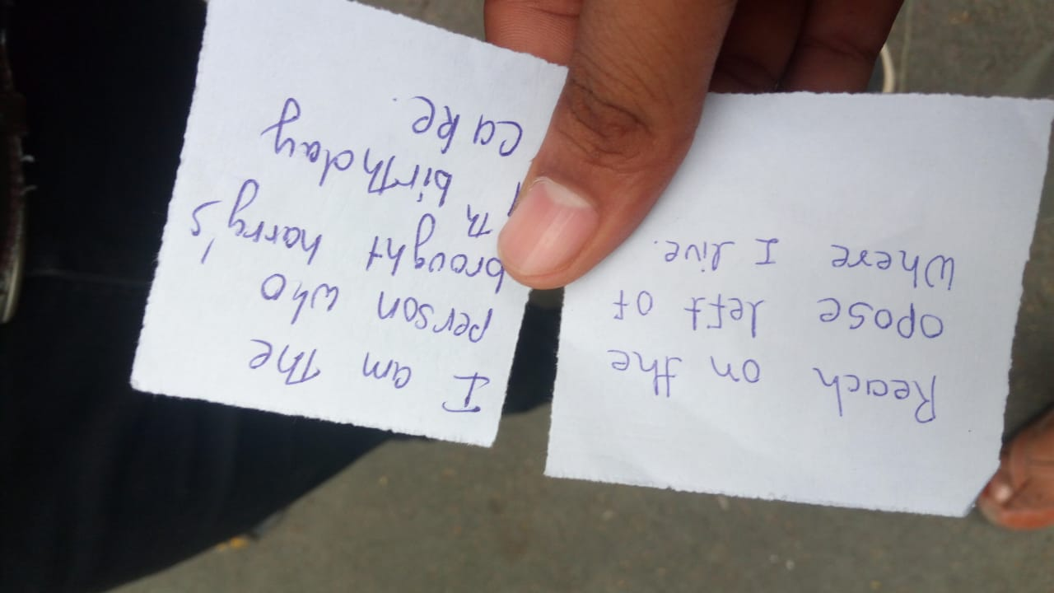  The Final Clue
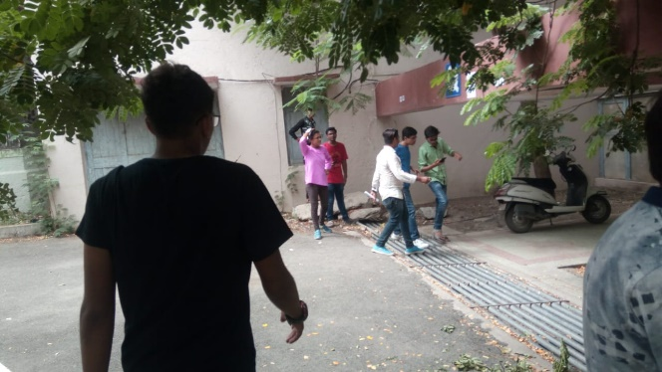
Participants Finding Props
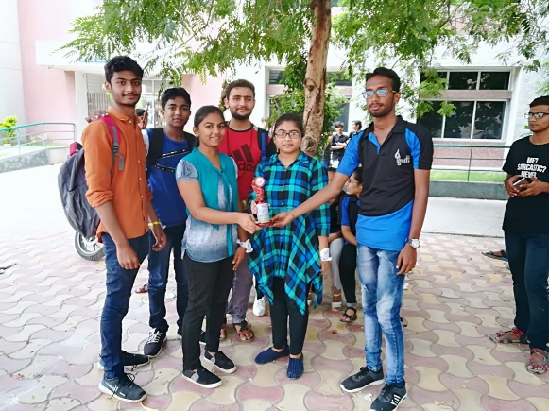
The Winning Team

